# Environment and inspiration

The environment is meant to represent an urban environment, with moving obstacles (pedestrians as an example), static obstacles (buildings in this case) and areas of high congestion (mainly public places with many people gathered). The environment could represent a part of any major city like New York or London.

Examples:

Ex. 1: Area around UCL:

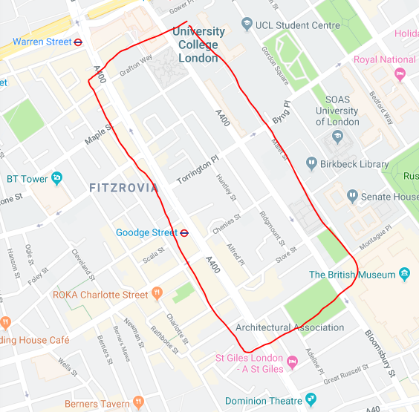

Ex. 2: Covent Garden:

